Given the financial clout of professional sport, it is little wonder that many athletes are tempted to turn professional after amateur wins. Boxing is perhaps the clearest example of a sport where athletes are faced with the fundamental amateur v pro debate: do they retain amateur status to live the dream of competing on home soil as Olympic boxers in the London 20102 Games, or take the tempting financial route of lucrative professional contracts and World Championship titles, with the downside of potentially entering the ring too fast than their experience and youth might ideally allow?

Image created by crashmaster007 and reproduced under a Creative Commons licence.

The sport of boxing has taken the bull by its’ metaphorical horns, and developed a World Series of Boxing, that gives amateur boxers a reason to retain their amateur status, at least until the next Olympic Games. This increases the potential for great young Olympic fighters to develop their skills in a supportive environment, to earn money as amateurs (an interesting concept in itself), to be eligible to fight in upcoming Olympic bouts, and to not have to depend on pro contracts to earn a living. The World Series of Boxing was devised by the Amateur International Boxing Association (AIBA).

AIBA proposes to fund the World Series via the sale of media rights, and has also asked for a £50,000 deposit from each city that wishes to take part.

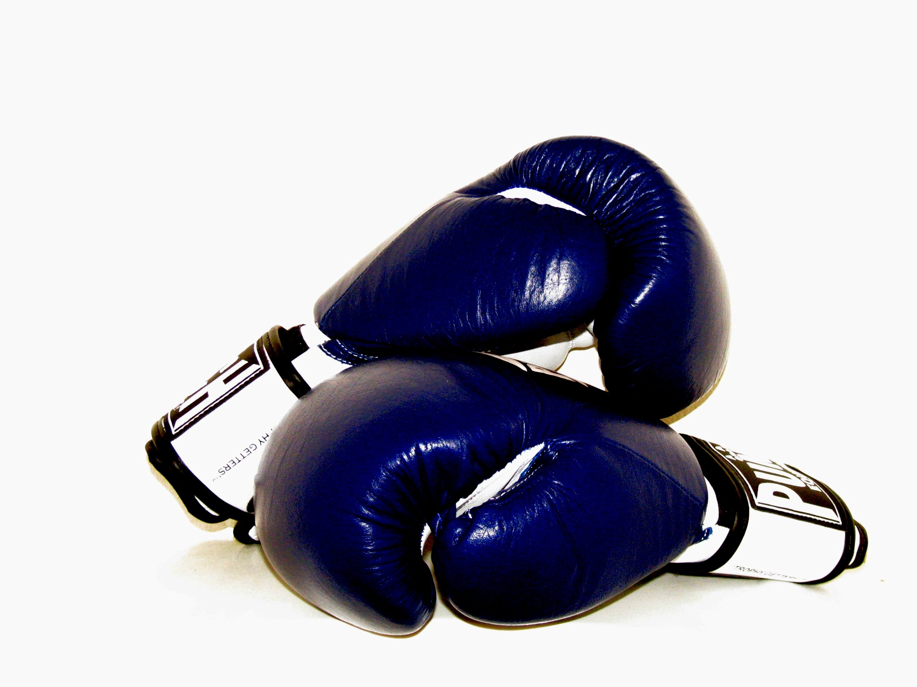
Image created by KayVee.Inc and reproduced under a Creative Commons licence.

Britain’s Knockout Blow

But British boxing chiefs have dealt a blow to any young British World Series hopefuls. The British Amateur Boxing Association (BABA) recently issued a statement saying that they are not in a financial position to commit to the £50,000 deposit, due to a shortfall of almost £1million that the sport is currently experiencing. Derek Mapp, Executive Chairman of the BABA, commented: "We remain in discussions but current financial circumstances mean it would be unwise for us to commit."

This is a real blow to athletes, as the competition could have earned them up to £200,000 a year towards their Olympic training, and pitted their skills against other Olympic hopefuls from countries such as the USA, Russia and Italy.

Start the Discussion
- Whose interests would it primarily serve?
- What do you think the ramifications of introduction of a World Series might be for both the professional and amateur sport?
- Do you think that this model might be applicable to other sports? Give reasons for your answer.

Find out more
AIBA News Release
http://www.aiba.org/default.aspx?pId=2703

CREDITS
© Oxford Brookes University 2010. oxb:060111:033dd

This resource was produced as part of the 2012 Learning Legacies Project managed by the HEA Hospitality, Leisure, Sport and Tourism Subject Centre at Oxford Brookes University and was released as an Open Educational Resource. The project was funded by HEFCE and part of the JISC/HE Academy UKOER programme. Except where otherwise noted above and below, this work is released under a Creative Commons Attribution only licence.

Exceptions to the Licence
The name of Oxford Brookes University and the Oxford Brookes University logo are the name and registered marks of Oxford Brookes University. To the fullest extent permitted by law Oxford Brookes University reserves all its rights in its name and marks, which may not be used except with its written permission.

The JISC logo is licensed under the terms of the Creative Commons Attribution-Non-Commercial-No Derivative Works 2.0 UK: England & Wales Licence. All reproductions must comply with the terms of that licence.

The Higher Education Academy logo and the HEA Hospitality, Leisure, Sport and Tourism Subject Centre logo are owned by the Higher Education Academy Limited and may be freely distributed and copied for educational purposes only, provided that appropriate acknowledgement is given to the Higher Education Academy as the copyright holder and original publisher.



Reusing this work
To refer to or reuse parts of this work please include the copyright notice above including the serial number. The only exception is if you intend to only reuse a part of the work with its own specific copyright notice, in which case cite that.

If you create a new piece of work based on the original (at least in part), it will help other users to find your work if you modify and reuse this serial number. When you reuse this work, edit the serial number by choosing 3 letters to start (your initials or institutional code are good examples), change the date section (between the colons) to your creation date in ddmmyy format and retain the last 5 digits from the original serial number. Make the new serial number your copyright declaration or add it to an existing one, e.g. ‘abc:101011:033dd’.

If you create a new piece of work or do not wish to link a new work with any existing materials contained within, a new code should be created. Choose your own 3-letter code, add the creation date and search as below on Google with a plus sign at the start, e.g. ‘+tom:030504’. If nothing comes back citing this code then add a new 5-letter code of your choice to the end, e.g.; ‘:01lex’, and do a final search for the whole code. If the search returns a positive result, make up a new 5-letter code and try again. Add the new code your copyright declaration or add it to an existing one.

